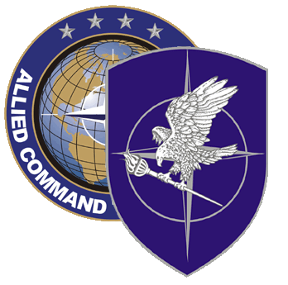
NATO SCHOOL: Global Leader in Multinational Military Education and Individual Training

p4-90 nato petroleum course

The aim of the NATO Petroleum Course is to train students of NATO and Partner Nations at the strategic, operational and higher tactical levels on all aspects of NATO petroleum matters resulting in greater competency of staff, more effective and efficient fuel supply planning for NATO and NATO-led military operations.

The training will allow participants to utilise NATO’s logistics policy, principles, doctrine and procedures and is applicable to all NATO and national fuels personnel assigned to NATO, national or international units and planners in Fuel Supply Planning agencies and headquarters on different command levels.

Course Length: 1 week

Offerings per year: 1

Class Size: 25 max

Security Clearance: NATO UNCLASSIFIED

Rank Limitation: OF-2 through OF-4 or civilian equivalent and assigned to a staff position as operator planner or engineer related to fuel supply.
Prerequisites:
a) Language proficiency: English IAW STANAG 6001 3333
b) Must be familiar with MS Word and Power Point

Course Objectives:
Upon completion of the course the student will be able to:
- Explain NATO Petroleum Organization and Responsibilities and its relationship with other NATO Logistics Bodies and International Organizations
- Summarize NATO Petroleum Doctrine
- Describe NATO Petroleum Crisis Management Organization and Procedures
- Explain the NATO Pipeline System including Operation and Maintenance Inspections (O&MI) and the Capability Package (CP) process
- Explain NATO Operational Fuel support concept and list some lessons learned from petroleum support to current and recent military operations /exercises.
- Summarize the concept of Energy Security in NATO and compare it with the global security of petroleum products.

